

**The Bridge Restaurant**

**FESTIVE MENU**

**Available from 20th November until 31st December**

**STARTERS**

**Soup of the Day** Served with bread and butter.

**Little & Cull Venison & Beef Shin Terrine**

Caramelised Onion Chutneyand ciabatta croutons

**Mackerel**

Mackerel and horseradish rillette served with roasted beetroot, lemon crème fraiche and crostini.

**Crispy panko Coated Camembert**

Served with cranberry compote and mixed leaves.

**MAIN COURSE**

**Turkey**

Turkey breaks ballotines served with haggis, pigs in blankets, garlic & thyme roast potatoes,

honey roast carrots & parsnips, shredded brussels sprouts, and cranberry jus

**Lamb Shank**

Mashed potatoes, honey roast carrots & parsnips, sprouts and red wine &rosemary

jus

**Scottish Fillet of Salmon**

Roast new potatoes, carrots & parsnips and sprouts champagne lemon butter sauce.

**Mushroom & Stilton Wellington**

Mushroom & Stilton Wellington, honey roast carrots & parsnips and

creamy blue cheese sauce

**DESSERTS**

**Christmas Pudding**

Traditional Christmas pudding with vanilla bean custard

**Cranachan**

Raspberry & whisky cream, toasted oats and honey

**Selection of Scottish Cheeses**

*Served with grapes, oatcakes, apple, celery and onion chutney.*

***I*ce Cream Selection**

**2 courses for £26.95**

**3 courses for £30.95**

**FOOD ALLERGIES NOTICE** IF YOU HAVE A FOOD ALLERGY OR A SPECIAL DIETARY REQUIREMENT, PLEASE

INFORM A MEMBER OF THE STAFF

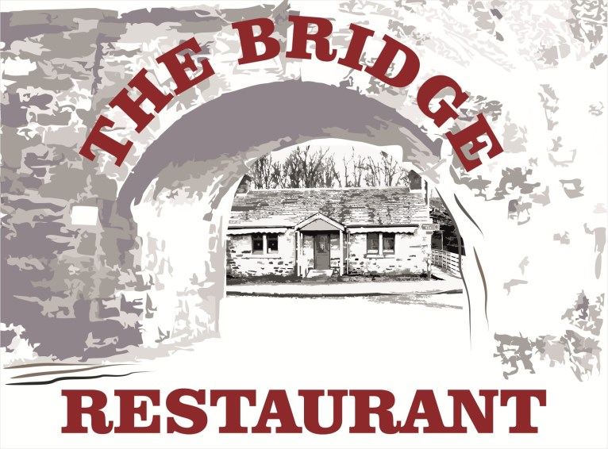



Pitlochry, Ferry Road, PH16 5DD

01796 473 539

thebridgeofpitlochry@gmail.com

booking@thebridgerestaurant.co.uk